C:\Users\traecit2\Desktop\excelsoft_logo.png

***creating a snapshot of a virtual machine***



| Document Details | |
| --- | --- |
| Type Of Information | **Document Data** |
| Document Title |  |
| Document Reference Number |  |
| Document Owner |  |
| Security Classification |  |
| Review Frequency |  |

| Document Approval | | | |
| --- | --- | --- | --- |
| Name | **Role** | **Signature** | **Date** |
| Mahesh Jambardi | Chief Operating Officer | Mahesh Jambardi |  |
| Srinivas Chudamani | Sr. Manager IT & IS Infrastructure | Srinivas Chudamani |  |

| Version Control Details | | | |
| --- | --- | --- | --- |
| Version  Number | **Revision Date** | **Prepared by** | **Nature of Change** |
| 1.0 |  |  |  |
| 2.0 |  |  |  |
| 3.0 |  |  |  |
| 4.0 |  |  |  |
| 4.1 |  |  |  |
| 4.2 |  |  |  |
| 4.3 |  |  |  |
| 5.0 |  |  |  |

**Table of Contents**

[**1.**](#_heading=h.30j0zll)  **4**

[**2.**](#_heading=h.2et92p0)  **4**

[**2.1.**](#_heading=h.tyjcwt)

[**3.**](#_heading=h.lnxbz9)  **9**

[**3.1.** 9](#_heading=h.35nkun2)

[**4.**](#_heading=h.1y810tw) **REFERENCE 11**

**Steps:**

# **Sign in to the Azure portal at portal.azure.com.**

* Navigate to Virtual Machines.
* Choose the virtual machine for which you want to create a snapshot by clicking on its name from the list of VMs.

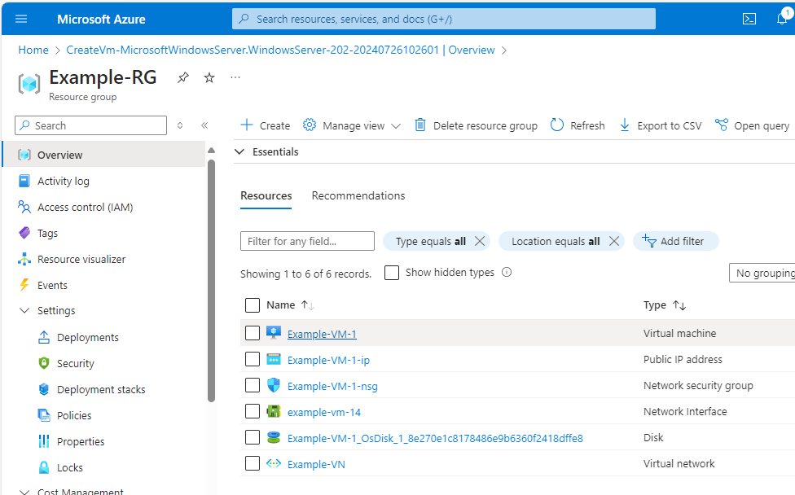

1. To select disk

* In left hand side under setting select disk
* Select the OS disk

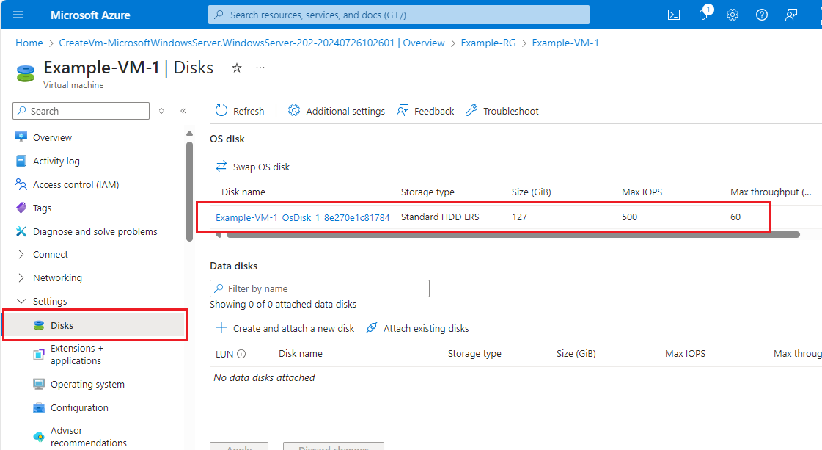

# **In the disk overview pane, Click on + Create snapshot to start the snapshot creation process.**

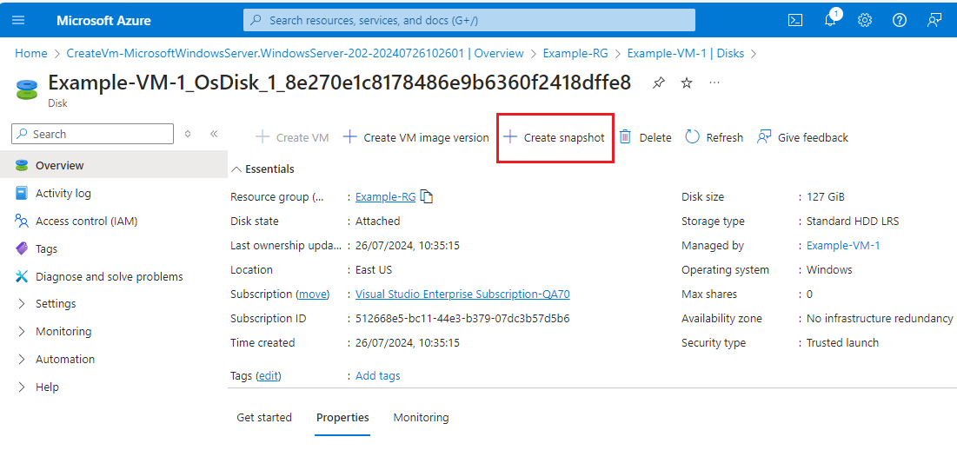

# 

# **Select a subscription for the snapshot.**

* Select a resource group for the snapshot.
* Enter a name for the snapshot.
* Snapshot Name format: DiskName-sanpshot-DDMMYYYY
* Snapshot type: Full
* Storage type: Standard HDD
* Click on **Review + create**.

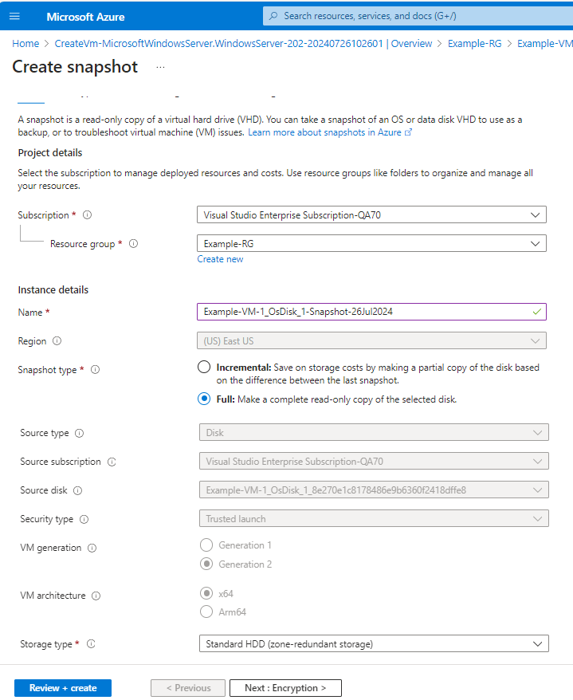

# **After the validation passes, click on Create to start the snapshot creation process.**

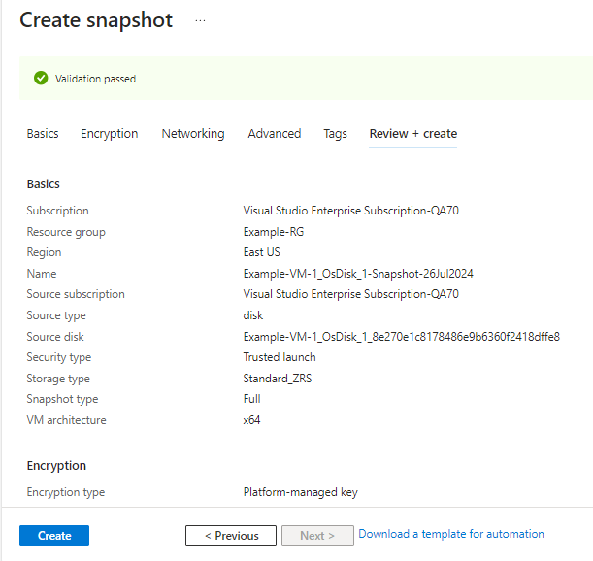

* Azure will begin creating the snapshot. You can monitor the progress on the notifications pane. This process typically takes a few minutes, depending on the size of the VM and its disks.

Once the snapshot is created successfully, it will appear in the Snapshots section of your virtual machine's overview pane.

Step 12: Click on Go to resource to view created snapshot in resource group



 